Other solutions.

1.

In other solutions that we had with this problematic was, adopting a tree, were people take care of a tree, and with an app have track of the evolution of this, having curiosities, helping information and other things about the type of tree the person had, so the people could have a sense of what they were doing.

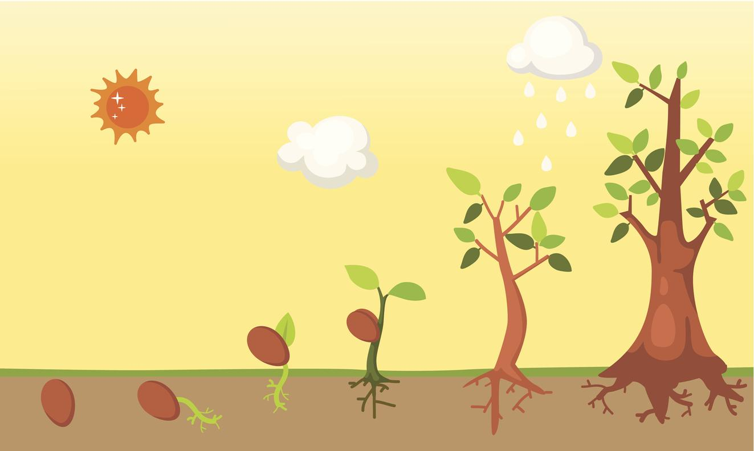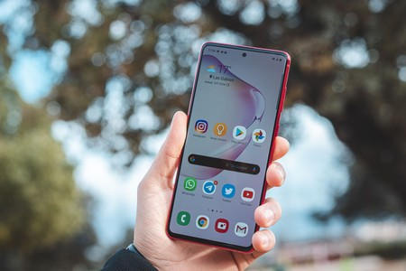

2.

Aswell, other thing we had in mind was having trips to the CICY(Yucatan Scientific Investigation Center), where people could have more information about the plants, and see a vivero of plants.

